**Foraging, fear and behavioural plasticity, a lesson from hummingbirds**

**Abstract**

Traditionally, foraging behaviour has been explained as the response to a trade-off between energetic gain from feeding resources and the potential costs from concomitant risks. However, increasing number of studies has shown that this view fail to explain an important fraction of the variation in foraging across a variety of taxa. One of potential mechanisms that may account for this variation is that various behaviours associated with foraging may have different fitness consequences and that may further depend on the environmental context. Here, we explored this mechanism by evaluating individual responses of long-billed hermit hummingbirds (*Phaethornis longirostris)* to food resource exploitation contexts with varying levels of risk. We quantified birds foraging efficiency with regard to three behaviours: a) exploration (number of feeders used during the foraging visit), b) risk avoidance (latency to start feeding) and c) arousal (amount of movements during the foraging visit) in conditions of two different levels of perceived predation risk (low – control, and high – experimental, with a threatening bullet ant model). As expected, foraging efficiency decreased in response to threatening conditions. However, exploration and arousal explained additional variation in foraging efficiency in a condition-dependent manner. More exploration was associated to higher foraging efficiency in control conditions, but this was reversed when exposed to a threat. Regardless of conditions, arousal was positively associated with foraging efficiency while risk-avoidance was negatively related. Importantly, exploratory behaviour and risk-avoidance were quite repeatable behaviours suggesting that they may be related to intrinsic differences between individuals. Our findings highlight the importance of taking into account for additional behavioral dimensions to better understand foraging strategies and the ecological interactions in which individual decisions can play a major role.

**Keywords**

risk allocation hypothesis, predator, prey, risk-avoidance, exploratory behaviour, arousal, repeatability

**Introduction**

A variety of ecological factors has been identified as major determinants in shaping animal’s foraging strategies (i.e. resource exploitation). Of those the most commonly evoked are the amount and distribution of available food resources (Morrison et al. 1990; Herborn et al. 2014) and animal motivation (both in the sense of marginal value theorem (Charnov 1976) and/or body condition (Bautista et al. 2001)), but predation pressure is also frequently considered (Lima and Bednekoff 1999). The intensity of a prey vigilance increases with the level of risk predation (probability of predator presence) affecting its foraging efficiency. As the risk allocation hypothesis imposes, a prey allocates time for foraging inversely proportionate to predation pressure (Lima and Bednekoff 1999; Verdolin 2006). Thus, in a given food resources–predation landscape, a fixed foraging strategy is expected to evolve (Krebs 1980). However, increasing number of studies demonstrates a high variation in foraging strategies (Patrick et al. 2014; Camprasse et al. 2017; Moldoff and Westneat 2017), which is hard to explain using only food- and predation-based arguments (Bautista et al. 2001).

Variation in foraging strategies of individuals remains an intriguing topic (Nussey et al. 2007; Bell et al. 2009; Dingemanse et al. 2009; Herborn et al. 2014; Alonzo 2015; Toscano et al. 2016). Existing evidence demonstrates not only the variation *per se* but consistent inter-individual differences in the average level of a behaviour displayed across a range of contexts (Carere and Maestripieri 2013) and in response to environmental variation (Nussey et al. 2007; Dingemanse et al. 2009). Within a species/population, individuals usually represent a full continuum of a given behavioural display, with two polar-opposite phenotypes (e.g. high and low exploratory behaviour) and various intermediate forms in between. Importantly, fitness advantages of the contrasting behaviours may differ in various contexts, sometimes dramatically (Smith and Blumstein 2008). For example, highly exploratory behaviour can be advantageous in conditions of resource competition but disadvantageous in a higher predation pressure environment (Dall et al. 2004; Réale et al. 2007; Smith and Blumstein 2008; Quinn et al. 2012b). Despite growing number of studies showing both directly and indirectly behavioural variability in the performance of various strategies, it is still not entirely recognized what could be fitness consequences of variation in these additional dimensions of behavior in foraging performance.

The fitness payoffs of a behavior is likely to be a main source of the observed variation in foraging strategy (Dingemanse and Réale 2005; Smith and Blumstein 2008; Moldoff and Westneat 2017). Under variable conditions, a diversity of behavioral strategies can be mantained when not a single one performes in an optimal way in all contexts. If so, performance may vary as a function of the interactions between social and/or ecological selective forces, which can help reveal the complex interplay of intrisic and extrinsic factors shaping behavioral variability (Bergeron et al. 2013; Le Cœur et al. 2015; Mouchet et al. 2021; Roth et al. 2021). Here, we examined the fitness consequences of various behavioural strategies during foraging in wild ranging, long-billed hermit hummingbirds (LBHs, *Phaethornis longirostris*). Hummingbirds are known for their extreme metabolism with a high need for energy intake that makes them constantly motivated to forage (Suarez 1992). As such, they are expected to be under strong selection for maximing foraging efficiency which can have an important effect on fitness. This is particularly significant for traplining foraging species, which use flowers dispersed across the habitat in a route-like fashion, a more unpredictable resource (Stiles and Wolf 1979; Araya-Salas et al. 2018). Free foranging foraging entails a period of high vulnerability, exploited by a wide range of predators (Stiles 1978; Owen and Cokendolpher 2006; Lorenz 2007; Zenzal et al. 2013; Sazima 2015; Nyffeler et al. 2017), which in turn, results in a trade-off between efficient foraging and risk avoidance. The differential payoffs in the selective landscape given by these two factors are expected to shape foraging strategies of the hummingbirds.

We assessed the payoffs of diferent behavioral strategies under a trade-off between food resource exploitation and risk avoidance in long-billed hermits. We considered the issue in the context of low and high level of perceived threat and in regard to three behavioural axes, commonly linked to the explotation of food resources: a) exploration (number of foraging spots (i.e. feeders) used during the foraging visit), b) risk-avoidance (latency to approach the foraging spot to forage), and c) arousal (amount of movements during the foraging event) (Réale et al. 2007; Smith and Blumstein 2008; Couchoux and Cresswell 2012; Quinn et al. 2012a; Herborn et al. 2014). We hypothesized that foraging efficiency varies under different threat conditions and that this variation would be modulated by the three behavioural axes evaluated. Overall, we expected that not a single behavioral strategy would provide the highest foraging efficiency across threat levels.

**Material and methods**

The long-billed hermit is arelatively large size hummingbird species of humid neo-tropical lowlands. This is species shows a lekking mating system in which males sing and display from traditional areas inside the forest for mate attraction during a ~8 month breeding season (Stiles & Wolf 1979). Unlike many hummingbirds, hermits do not defend a patch of flowers but visit widely scattered flowers in a foraging route (i.e. traplining). Aggressive interactions related to disputes over lek territories are common (Araya-Salas et al. 2018). Floaters can be found singing from perches of territorial males while the latter are absent foraging. Territorial ownership is typically regained after an aggressive interaction with intruders, suggesting a selective pressure to reduce foraging time and increase territory attendance. Indeed, more efficient foraging males are more likely to own a lek territory (Araya-Salas et al. 2018).

*Fieldwork.* We carried out the study at La Selva Biological Station, Costa Rica (10 o23’ N, 84o10’ W) between May and June 2015. We captured and individually marked 21 individuals with foam tags (total weight of 0.02 g, which is ~0.3 % of LBH body mass, 6g) with unique colour combinations, attached to the bird back and chest with nontoxic eyelash glue (Araya-Salas et al. 2018). To habituate birds to the study design, we exposed them to commercial hummingbird feeders (900 ml, the model: Perky Pet #209B, modified to have a single opening for accessing “nectar”), located in a distance of ca 100 m from the lek border. Location of the feeders did not overlap with foraging area of all the captured individuals, as in total we had 12 visitors at the feeders area, while all marked birds were observed on the lek after being caught either defending territory or as floaters (i.e. all of them survived the capturing and marking procedure).

To evaluate foraging efficiency in long-billed hermits and quantify it in low and high threat context, we applied a field experiment using a set-up of three feeders (as described above), filled up with ~30% sugar-water and arranged in a line (separated by ca 10 cm distance from each other, Fig. 1; Supplementary materials: videos S1 and S2). The experiment session consisted of two consecutive phases performed on the same day, in the low (first phase, control) and high threat contexts (second phase, experimental). During the whole experiment birds were allowed to forage on the nectar spontaneously and their behaviour was recorded by a commercial camera (continuous recording mode; model: Fujifilm HS30). We attached a dead bullet ant (*Paraponera clavata*; found dead in the forest) to feeders during the second phase, to simulate a threat. Although the ant is not a predator of hummingbirds its presence in flowers often scares other hummingbird species while long-billed hermits appear more hesitant to feed (M.A.S., pers. obs, suppl. mat. videos 1 and 2). Importantly, attached bullet ants did not completely scare birds off, allowing the quantification of their foraging behaviour in these circumstances. Hence attaching bullet ant to feeders was expected to resemble situations of increased risk of being injured while still exploiting the feeding resource.

We performed three complete experiment sessions (with two phases) and two incomplete sessions (with one phase only, due to weather conditions), all within two weeks (with 2-3 days between sessions). The two complete (two phases) and two incomplete sessions (with control phase) were conducted in the mornings when the foraging activity peak occurs (Stiles & Wolf, 1979), and only a single complete experiment session was performed during an afternoon, when the activity is lower. The time of the day did not affect foraging effiency considerably (generalizd mixed effect model: foraging efficiency ~ hour (fixed effect; numeric) + birdID (random effect; estimate: -0.009 ± SE 0.005, t = -1.74, df = 137.97, P = 0.08). Besides, since each experiment session was completed within three hours, experimental and control phases where performed roughly at the same time of the day and thus any potential day effect should not bias comparsions of the experimental and control phases.

The duration of control phases, including those from incomplete sessions, varied from 0.5 to 3 hours. Owing to regular visits of birds in these control conditions (ranging from 1 to 12 per hour per individual), we could record multiple visits of focal individuals, on average in total of 6 visits per individual (range 2-18). For experimental phases, we kept recording until all visitors observed during the preceding control phase returned to the feeders, resulting in an average of 3 visits per individual during this phase (range: 1-7). The control phase was performed always before the experimental one as doing so we could ensure recruitment of individuals to both phases. The presence of the bullet ant on their very first encounter with the feeders in a given day might preclude birds to explore the resource. To mitigate the potentially negative effect of bullet ant exposure on the frequency of visits, we performed the sessions with 2-3 days in between. However, with such a experimental design we could not randomize treatments and controls phases. The fixed sequence of the experiment phases could bias results on foraging efficiency if that would decrease over the time of experiment session (e.g. due to satiation). To adress this concern, we analysed foraging efficency over the consecutive visit using data from control phases (see Supplementary Materials), and we found that indeed foraging efficiency may change over the time but that apparently happens only after a considerable number of visits of an individual. Since in our data set it was only the issue with single individuals at single control phases, we considered that issue of not particular importance. Besides, foraging efficency improved over the time, and given the fact that experiments with bullet ants were always performed after the control phases, a negative effect of the experimental treamtent could be only mitigated (i.e. increase or no difference instead of decrease in foraging efficency would be observed). Since that did not happen, the results of the experiment are apparently solid (Supplementary Materials, Fig. S1 and S2). Consequently, we treated all the visits of particuar individuals as independent data points.

*Videos analysis.* We screened the video recordings with VLC software (www.videolan.org), to locate and cut out video fragments with foraging visits of focal birds. Events of two or more individuals (long-billed hermits or a different species) visiting the feeders at the same time were uncommon and were excluded from analysis as interactions disrupted their regular foraging behaviour. A foraging visit was considered whenever a bird inserted the bill into a feeder at least once. For each bird’s visit we established key time-points (white and black circles on Fig. 1), with 0.1 seconds precision, using Cowlog software (Pastell 2016). Based on these time-points we calculated the duration of latency to forage, defined as the interval between appearance in the feeder area (when started to hover in front of the feeder in a distance of ca 0.5 m) and the onset of foraging (time from *a* to *b* on Fig. 1); duration of feeding interval/s (time from *b* to *c* on Fig. 1; on average 4.9 events, with a range of 1-26); duration of feeding break/s (time from *c* to *d* on Fig. 1); duration of total foraging (time from *b* to *e*, Fig. 1) and duration of total foraging visit (time from *a* to *e* on Fig. 1). For each visit we also noted which and how many times each of the three feeders were used by the focal bird.

To quantify bird movements around the feeders, we took advantage of the line-arrangement of the feeders that greatly restricted birds activity within two axis. That simplified further analyses, as operating in two-dimensional space we could establish Cartesian coordinates of a bird position for each video frame using the software Tracker version 5.1.5 (physlets.org/tracker). Based on those coordinates we calculated distances between each two bird’s positions using Pythagoras theorem.

*Parameters.* We calculated foraging efficiency as the ratio of the total duration of foraging (sum of the duration of all feeding intervals) to the total duration of the foraging visit. To characterize foraging strategies we measured three behavioural features that have been linked to intrisic individual characteristics in other species and shown to affect foraging: exploration, risk-avoidance and arousal (Réale et al. 2007; Smith and Blumstein 2008; Couchoux and Cresswell 2012; Quinn et al. 2012a; Herborn et al. 2014). As a proxy for **exploration** we utilized the rate of visited feeder; the number of feeders divided by the total duration of the visit as visits to new feeders are likely to be a function of time spend at the feeders. As a proxy for **risk-avoidance** we used latency to start to forage, as defined above (time from *a* to *b* on Fig. 1). For both parameters, the higher the value, the stronger was the exhibited behaviour. As **arousal** we considered the coefficient of variance in spatial distances covered by an individual during the whole foraging visit, divided by the number of visited feeders. Therefore, it represents the mean distance covered while visiting a feeder. Higher distances were related to the higher arousal.

*Data analysis.* All the analyses were performed in R (R Core Team 2019). Since all parameters had skewed distribution, we log-transformed them prior to analyses (Fig. S2). We estimated the repeatability of foraging efficiency, exploration, risk-avoidance, and arousal using *rptR* package (Stoffel et al. 2017). For that we used behavioural features measured during the low risk treatment only, which represented undisturbed conditions and for which we recorded multiple visits per individual. While fitting the repeatability model, we considered given behavioural variable (response variable) and birds identity [explanatory variable/random effect, (Stoffel et al. 2017)]. We assessed variation in foraging efficiency (response variable) as a function of threat level and intrinsic behavioural features (exploration, latency and arousal as predictors) using a Bayesian generalized linear mixed model with individuals as a random effect. We fitted three models representing alternative hypothesis explaining variation in foraging efficiency. The first model represent a more traditional view of foraging behaviour in which efficiency is only affected by the level of threat. The second model included an interaction among behavioural traits and threat level, which represents a more nuanced scenario in which the interplay between threat level and intrinsic behavioural differences determines foraging efficiency. There was only little collinearity between predictors (correlation coefficient range from -0.21 to -0.10; Fig. S3). Finally, we also fitted an intercept-only model representing the scenario in which the proposed predictors do not affect efficiency. These three alternative models were compared using model selection based on the deviance information criteria (DIC) (Meyer 2016). Models were run with single predictor for intrinsic behavioural traits (arousal, exploration and risk-avoidance) as well as in a global model with all behavioural predictors included. The two approaches yield qualitatively similar results, therefore we presented here only the outcome of the global model. while the outcome of the single behaviour-predictor models are presented in Supplementary Materials, Table S1, Table S2, Fig. S4). Models were fitted using the R package *MCMCglmm* (Hadfield 2010).

**Ethical note**

All activities (birds marking, feeding, and video recording/observations) were performed with the greatest care. The capturing and marking procedure did not have apparent effect on birds survival, as all the individuals where observed in the lek and/or at the feeders area after the capturing. The foam with with the birds were marked was of negligible weight (0.02 g, which constitutes ~0.3% of average body mass (6g) of LBH). The study was reviewed and authorized by the Costa Rican Ministerio del Ambiente y Energia (063-2011-SINAC), and performed in accordance with their guidelines and regulations.

**Results**

Repeatabilityof all the parameters was moderate but significant for all the parameters except for arousal (Fig. 2). When predicting foraging efficiency, the model including all intrinsic behavioural traits and their interaction with the risk predation context performed significantly better than a simpler model including only threat context (Table 1). All parameters and their interaction were significant in this model except for risk-avoidance (Table 2). Overall, foraging efficiency was lowered in the higher threat context (Fig. 3) but was also affected by the birds’ exploratory behaviour and arousal. Importantly, the effect of behavioural parameters on the foraging efficiency was context dependent (Table 2). The most dramatic effect was found in exploratory behaviour, which was positively related to foraging efficiency in low threat context but the opposite pattern was observed in the higher threat context (Fig. 4). Arousal was positively related to foraging efficiency and this was particularly pronounced when birds faced higher threat (Fig. 4). Risk avoidance tended to lower foraging efficiency and did not differ between threat levels (Fig. 4).

**Discussion**

As we could expect under the risk allocation hypothesis (Lima and Bednekoff 1999) foraging efficiency of long-billed hermits decreased in response to threatening conditions. However, behavioural performance in regard to exploration, risk-avoidance and arousal additionally affected the foraging efficiency, interestingly, in a condition-dependent manner. These results suggest that a range of strategies instead of a single fixed strategy should be considered, when modelling foraging behaviour in a threatening context. The results also highlight the importance of behavioural variability in shaping evolution of foraging strategy.

Despite not being a specific prey target, hummingbirds may be opportunistically hunted by a wide range of predators (e.g. Owen and Cokendolpher 2006; Lorenz 2007; Zenzal et al. 2013; Sazima 2015; Nyffeler et al. 2017). That imposes a considerable predation risk and favours evolution of risk-avoidance behaviour. Indeed, we found that experimental exposure of an ant, potentially representing just a threat of being bitten (but not eaten), was enough for LBHs to exhibit higher risk-avoidance (longer latency to start to forage) and lower movement activity compared to the control conditions. Importantly, despite of the threat, birds did forage although with a lower efficiency. This places LBHs in a group of species representing so call paradox of risk-allocation hypothesis - in conditions of a frequent predator presence, prey might need to forage actively even though a threat (either potential or real predator) is present (Lima and Bednekoff 1999; Ferrari et al. 2009). It is worth to evoke in that context one of assumptions of the risk allocation hypothesis, which is ‘living on the edge’ in terms of meeting energy demands (Lima and Bednekoff 1999; Verdolin 2006). This assumption seems to be rarely met in most of animal species used to test the hypothesis so far ((Ferrari et al. 2009)). Hummingbirds, given their extreme metabolism rate, could be a rare example when the assumption is actually true.

The changes in LBHs behaviour in response to a threat, longer latency and lower arousal, are likely to be adaptive. A longer time spent at the foraging site before the feeding onset may allow an individual to thoroughly evaluate the risk-level and so to make adequate foraging decision. If a threat is not considered mortal, as it was likely the case in the present study, the individual initiates foraging despite being threaten, otherwise it might search for another food resource or postpone foraging event. Decreased activity (lower arousal) in the high-risk condition may lower chances of being spotted and so hunted by a predator. Indeed, decreased movement activity is expected in the light of the risk allocation hypothesis (Lima and Bednekoff 1999) with some evidence supporting this prediction (e.g. Sih and McCarthy 2002 but see other examples reviewed in (Ferrari et al. 2009). This prediction may not be fully applicable for the LBHs however, as here, the prey was in a full exposure to the threat (i.e. “already spotted by a predator”). An alternative explanation of the lowered arousal in the context of elevated risk could be a cognitive overload associated with the need to evaluate the risk situation, which could, in turn, affect locomotor activity. The exploratory behaviour was similar regardless of the circumstances, which may be surprising if to assume that less exploratory behaviour would be expected in threatening conditions for the same reasons as for the arousal (Ferrari et al. 2009). This lack of differences in the exploratory behaviour between control and experimental conditions could be explained in the context of birds personality (see below).

Each of the examined behaviours affected foraging efficiency, and in case of the exploratory behaviour the effect was dependent on the circumstances. In control conditions individuals exhibiting more exploratory behaviour had also overall higher efficiency during the foraging visit. Reversed pattern was observed for the experimental conditions. A simple reason of the reversed pattern could be that each time an individual stopped feeding to change feeder it had longer time intervals, probably associated with the need to analyse “*de novo*” the risk situation. The fact, that individuals were consistent over the time and context in their exploration suggests that this behaviour may be related to personality (Dingemanse and Réale 2005; Réale et al. 2007; Dingemanse et al. 2010; Montiglio et al. 2015). If indeed the exploratory behaviour examined here is a personality trait, and that trait has different fitness consequences in regard to predation, the predation pressure is likely to shape distribution of exploration phenotypes in the population. Although we are not able to test this prediction currently, to encourage future studies, we highlight the role of predators in the evolution of personality (Dingemanse and Réale 2005; Exnerová et al. 2010; Nácarová et al. 2018).

Risk-avoidance negatively affected foraging efficiency, meaning that individuals exhibiting high risk-aversion might jeopardize their survival in terms of energy intake while individuals with low-risk aversion, although benefiting from high foraging efficiency, would be more likely to be predated. The fitness consequences of this trade-off are obviously condition dependent. If the risk-avoidance, as measured in the present study (i.e. latency to initiate foraging), was related to birds personality, the relationship between that and foraging efficiency would contribute in the selection of given behavioural phenotype in given predation risk level. Consistently, frequent changes and/or unpredictable level of risk predation in the environment would maintain variability in this behavioural phenotype (Smith and Blumstein 2008).

To maximize fitness, hummingbirds should adaptively allocate both the exploratory and risk-avoidance behaviour. Given results of our study, we could try to predict differences in foraging strategy between two groups of hummingbirds of potentially distinct foraging strategy, trappliners and territorials. Obviously, making these differences precise we would be too much speculative. However, numerous differences in foraging strategy of trappliners and territorials could be listed (Gill 1988; Ohashi and Thomson 2005; Tello-Ramos et al. 2015) and our study would simply suggest a possible importance of predator pressure in shaping these differences.

An increasing foraging efficiency with an increase in arousal maybe counterintuitive at first glance, time allocated to movements potentially limits the time for foraging. However, arousal was not a repeatable trait, thus an animal arousal may be an outcome of its nutritional state, and more active individuals could be more effective during the foraging, owing to their good body condition.

Both exploratory and risk-avoidance behaviour were quite repeatable for individuals suggesting that these two behaviours are potentially related to birds personality (Sih et al. 2004; Dingemanse and Réale 2005; Cleasby et al. 2015). Three different groups in foraging efficiency in response to experimental threatening (increased, decreased and unchanged foraging efficiency, Fig. 2) additionally suggest that individuals respond to given conditions in different way, possibly depending on their personality. Thus, in a constantly changing environment, varying fitness consequences of given behavioural phenotype would maintain variation in animals personality (Smith and Blumstein 2008). If indeed the exploratory and risk-avoidance behaviour are at least partially heritable personality traits, one could use them to model an evolutionary scenario for given behavioural phenotypes in various conditions of predation pressure. We are currently not able to perform any analysis of that kind given the relatively low number of tested individuals but we point out hummingbirds as potential animal model species in the studies of animals personality.

**Acknowledgements** The study was funded by…. We thank … for assistance in field work.

**Author Contributions** Authors equally conceived the study, contributed to data collection, data analysis and manuscript writing.

**References**

Alonzo SH (2015) Integrating the how and why of within-individual and among-individual variation and plasticity in behavior. Curr Opin Behav Sci 6:69–75

Araya-Salas M, Gonzalez-Gomez P, Wojczulanis-Jakubas K, et al (2018) Spatial memory is as important as weapon and body size for territorial ownership in a lekking hummingbird. Sci Rep 8:. doi: 10.1038/s41598-018-20441-x

Bautista LM, Tinbergen J, Kacelnik A (2001) To walk or to fly? How birds choose among foraging modes. Proc Natl Acad Sci U S A 98:1089–1094. doi: 10.1073/pnas.98.3.1089

Bell AM, Hankison SJ, Laskowski KL (2009) The repeatability of behaviour: a meta-analysis. Anim Behav 77:771–783. doi: 10.1016/j.anbehav.2008.12.022

Bergeron P, Montiglio PO, Réale D, et al (2013) Disruptive viability selection on adult exploratory behaviour in eastern chipmunks. J. Evol. Biol. 26:766–774

Camprasse ECM, Cherel Y, Bustamante P, et al (2017) Intra-and inter-individual variation in the foraging ecology of a generalist subantarctic seabird, the gentoo penguin. Mar Ecol Prog Ser 578:227–242. doi: 10.3354/meps12151

Carere C, Maestripieri D (2013) No Animal Personalities. The University of Chicago Press

Charnov EL (1976) Optimal foraging, the Marginal Value Theorem. Theor Popul Biol 9:739–752

Cleasby IR, Nakagawa S, Schielzeth H (2015) Quantifying the predictability of behaviour: statistical approaches for the study of between-individual variation in the within-individual variance. Methods Ecol Evol 6:27–37. doi: 10.1111/2041-210X.12281

Couchoux C, Cresswell W (2012) Personality constraints versus flexible antipredation behaviors: How important is boldness in risk management of redshanks (Tringa totanus) foraging in a natural system? Behav Ecol 23:290–301. doi: 10.1093/beheco/arr185

Dall SRX, Houston AI, McNamara JM (2004) The behavioural ecology of personality: consistent individual differences from an adaptive perspective. Ecol Lett 7:734–739. doi: 10.1111/j.1461-0248.2004.00618.x

Dingemanse NJ, Kazem AJN, Reale D, Wright J (2009) Behavioural reaction norms: animal personality meets individual plasticity. Trends Ecol Evol 25:81–89. doi: 10.1016/j.tree.2009.07.013

Dingemanse NJ, Kazem AJN, Wright J, Biologiques S (2010) Evolutionary and ecological approaches to the study of personality. 3937–3946. doi: 10.1098/rstb.2010.0222

Dingemanse NJ, Réale D (2005) Natural selection and animal personality. Behaviour 142:1165–1190

Exnerová A, Svádová KH, Fučíková E, et al (2010) Personality matters: Individual variation in reactions of naive bird predators to aposematic prey. Proc R Soc B Biol Sci 277:723–728. doi: 10.1098/rspb.2009.1673

Ferrari MCO, Sih A, Chivers DP (2009) The paradox of risk allocation: a review and prospectus. Anim Behav 78:579–585. doi: 10.1016/j.anbehav.2009.05.034

Gill FB (1988) Trapline foraging by hermit hummingbirds: competition for an undefended, renewable resource. Ecology 69:1933–1942. doi: 10.2307/1941170

Hadfield JD (2010) MCMCglmm: MCMC Methods for Multi-Response GLMMs in R. J Stat Softw 33:1–22

Herborn KA, Heidinger BJ, Alexander L, Arnold KE (2014) Personality predicts behavioral flexibility in a fluctuating, natural environment. Behav Ecol 25:1374–1379. doi: 10.1093/beheco/aru131

Krebs JR (1980) Optimal foraging, predation risk and territory defence. Ardea 68:83–90. doi: 10.5253/arde.v68.p83

Le Cœur C, Thibault M, Pisanu B, et al (2015) Temporally fluctuating selection on a personality trait in a wild rodent population. Behav Ecol 26:1285–1291. doi: 10.1093/beheco/arv074

Lima SL, Bednekoff PA (1999) Temporal variation in danger drives antipredator behavior: the predation risk allocation hypothesis. Am Nat 153:649–659. doi: 10.1086/303202

Lorenz S (2007) Carolina mantind (Stagmomantis carolica) captures and feeds on a broad-tailed hummingbird (Selasphorus platycercus). Bull Texas Ornithol Soc 40:1–40

Meyer R (2016) Deviance Information Criterion ( DIC ) . Wiley StatsRef Stat Ref Online 1–6. doi: 10.1002/9781118445112.stat07878

Moldoff DE, Westneat DF (2017) Foraging sparrows exhibit individual differences but not a syndrome when responding to multiple kinds of novelty. Behav Ecol 28:732–743. doi: 10.1093/beheco/arx014

Montiglio P, Sih A, Mathot KJ, et al (2015) Animal personality and state – behaviour feedbacks: a review and guide for empiricists. Trends Ecol Evol 30:50–60. doi: 10.1016/j.tree.2014.11.004

Morrison MM, Raplph CJ, Verner J, Jehl JRJ (1990) Avian Foraging: theory, methodology and applications

Mouchet A, Cole EF, Matthysen E, et al (2021) Heterogeneous selection on exploration behavior within and among West European populations of a passerine bird. Proc Natl Acad Sci U S A 118:1–6. doi: 10.1073/pnas.2024994118

Nácarová J, Veselý P, Fuchs R (2018) Effect of the exploratory behaviour on a bird’s ability to categorize a predator. Behav Processes 151:89–95. doi: 10.1016/j.beproc.2018.03.021

Nakagawa S, Schielzeth H (2010) Repeatability for Gaussian and non-Gaussian data: a practical guide for biologists. Biol Rev 85:935–956. doi: 10.1111/j.1469-185X.2010.00141.x

Nussey DH, Wilson AJ, Brommer JE (2007) The evolutionary ecology of individual phenotypic plasticity in wild populations. J Evol Biol 20:831–844. doi: 10.1111/j.1420-9101.2007.01300.x

Nyffeler M, Maxwell MR, Remsen J V. (2017) Bird predation by praying mantises: a global perspective. Wilson J Ornithol 129:331–344. doi: 10.1676/16-100.1

Ohashi K, Thomson JD (2005) Efficient harvesting of renewing resources. Behav Ecol 16:592–605. doi: 10.1093/beheco/ari031

Owen JL, Cokendolpher JC (2006) Tailless Whipscorpion (Phrynus longipes) feeds on Antillean crested hummingbird (Orthorhyncus cristatus). Wilson J Ornithol 118:422–423. doi: 10.1676/05-062.1

Pastell M (2016) CowLog – cross-platform application for coding behaviours from video. J. open Res. Softw. 25:1–4

Patrick SC, Bearhop S, Grémillet D, et al (2014) Individual differences in searching behaviour and spatial foraging consistency in a central place marine predator. Oikos 123:33–40. doi: 10.1111/j.1600-0706.2013.00406.x

Quinn JL, Cole EF, Bates J, et al (2012a) Personality predicts individual responsiveness to the risks of starvation and predation. Proc R Soc B Biol Sci 279:1919–1926. doi: 10.1098/rspb.2011.2227

Quinn JL, Cole EF, Bates J, et al (2012b) Personality predicts individual responsiveness to the risks of starvation and predation. Proc R Soc B 279:1919–1926. doi: 10.1098/rspb.2011.2227

R Core Team (2019) R: A language and environment for statistical computing. R

Réale D, Reader SM, Sol D, et al (2007) Integrating animal temperament within ecology and evolution. Biol Rev 82:291–318. doi: 10.1111/j.1469-185X.2007.00010.x

Roth AM, Dingemanse NJ, Nakagawa S, et al (2021) Sexual selection and personality: Individual and group-level effects on mating behaviour in red junglefowl. J Anim Ecol 90:1288–1306. doi: 10.1111/1365-2656.13454

Sazima I (2015) Lightning predator: the ferruginous pygmy owl snatches flower-visiting hummingbirds in southwestern Brazil. Rev Bras Ornitol 23:12–14

Sih A, Bell A, Johnson JC (2004) Behavioral syndromes : an ecological and evolutionary overview. Trends Ecol Evol 19:372–378. doi: 10.1016/j.tree.2004.04.009

Sih A, McCarthy TM (2002) Prey responses to pulses of risk and safety: Testing the risk allocation hypothesis. Anim Behav 63:437–443. doi: 10.1006/anbe.2001.1921

Smith BR, Blumstein DT (2008) Fitness consequences of personality: a meta-analysis. Behav Ecol. doi: 10.1093/beheco/arm144

Stiles FG (1978) Possible specialization for hummingbird-hunting in the Tiny Hawk. Auk 95:550–553

Stiles FG, Wolf LL (1979) Ecology and evolution of lek mating behavior in the Long-tailed Hermit hummingbird. Ornithol Monogr 27:78. doi: http://dx.doi.org/10.2307/40166760

Stoffel MA, Nakagawa S, Schielzeth H (2017) rptR: repeatability estimation and variance decomposition by generalized linear mixed-effects models. Methods Ecol Evol 8:1639–1644. doi: 10.1111/2041-210X.12797

Suarez RK (1992) Hummingbird flight: Sustaining the highest mass-specific metabolic rates among vertebrates. Experientia 48:565–570. doi: 10.1007/BF01920240

Tello-Ramos MC, Hurly TA, Healy SD (2015) Traplining in hummingbirds: Flying shortdistance sequences among several locations. Behav Ecol 26:812–819. doi: 10.1093/beheco/arv014

Toscano BJ, Gownaris NJ, Heerhartz SM (2016) Personality , foraging behavior and specialization: integrating behavioral and food web ecology at the individual level. Oecologia. doi: 10.1007/s00442-016-3648-8

Verdolin JL (2006) Meta-analysis of foraging and predation risk trade-offs in terrestrial systems. Behav Ecol Sociobiol 60:457–464. doi: 10.1007/s00265-006-0172-6

Zenzal TJ, Fish AC, Jones TM, et al (2013) Observations of Predation and Anti-Predator Behavior of Rubythroated Hummingbirds During Migratory Stopover. Southeast Nat 12:N21–N25. doi: 10.1656/058.012.0416

**Table 1**. Ranking of models explaining foraging efficiency of long-billed hermits, ordered by delta Deviance Information Criterion (DIC; Akaike’s Information Criterion AIC yields to same conclusions).

|  |  |  |  |  |  |  |  |
| --- | --- | --- | --- | --- | --- | --- | --- |
| Predictors | df | DIC | ΔDIC | weight DIC | AIC | ΔAIC | weight AIC |
| md_all_interactions | 10 | -400.0909 | 0.00 | 1 | -396.3073 | 0.00 | 0.99 |
| md_arousal_exploration | 8 | -388.2385 | 11.85 | 0 | -386.2831 | 10.02 | 0.01 |
| md_arousal_risk_avoidance | 8 | -378.9807 | 21.11 | 0 | -376.8184 | 19.49 | 0.00 |
| md_arousal | 6 | -363.3410 | 36.75 | 0 | -363.2509 | 33.06 | 0.00 |
| md_risk_avoidance_exploration | 8 | -350.1568 | 49.93 | 0 | -348.8140 | 47.49 | 0.00 |
| md_exploration | 6 | -345.7716 | 54.32 | 0 | -346.4065 | 49.90 | 0.00 |
| md_risk_avoidance | 6 | -315.2258 | 84.87 | 0 | -315.0929 | 81.21 | 0.00 |
| md_context | 4 | -308.6036 | 91.49 | 0 | -310.7995 | 85.51 | 0.00 |
| md_null | 3 | -296.3098 | 103.78 | 0 | -299.8347 | 96.47 | 0.00 |

**Table 2.** Effects of behavioural variables and experimental context (low/high risk) on foraging efficiency of long-billed hermits. Effects are slope estimates derived from the fist top Bayesian MCMC generalized linear model (Table 1).

|  |  |  |  |  |  |  |  |
| --- | --- | --- | --- | --- | --- | --- | --- |
| Predictor | Effect size | CI 2.5% | CI 97.5% | pMCMC | intercept | N indv | N obs |
| contextHigh risk | -0.1409 | **-0.2732** | **-0.0132** | 0.0322 | 0.4548 | 11 | 192 |
| arousal | 0.0684 | **0.0275** | **0.1083** | 0.0006 | 0.4548 | 11 | 192 |
| exploration | 0.3686 | **0.1244** | **0.6167** | 0.0023 | 0.4548 | 11 | 192 |
| risk_avoidance | -0.0327 | -0.0663 | 0.0023 | 0.0641 | 0.4548 | 11 | 192 |
| contextHigh risk:arousal | 0.2445 | **0.1541** | **0.3436** | 0.0001 | 0.4548 | 11 | 192 |
| contextHigh risk:exploration | -0.8355 | **-1.1641** | **-0.4925** | 0.0001 | 0.4548 | 11 | 192 |
| contextHigh risk:risk_avoidance | -0.0270 | -0.0793 | 0.021 | 0.2918 | 0.4548 | 11 | 192 |

**Figure 1.** Scheme of the foraging visit – the total time spent by focal bird at the feeders area with at last one feeding event. Time-points crucial for the data analysis denoted with black circles and labelled with letters to denote particular events, being components of the foraging visit: **a)** onset of the foraging visit (appearance in the feeder area, usually hovering in front of the feeder); **b)** and **d)** onsets of consecutive feeding events (i.e. inserting the bill into the flower-hole of the feeder; **c)** end of the feeding event (i.e. removal of the bill from the flower-hole of the feeder); e) end of the foraging visit (i.e. the end of the very last feeding event during the foraging visit). Multiple feedings intervals were possible (1-26, mean: 4.9).

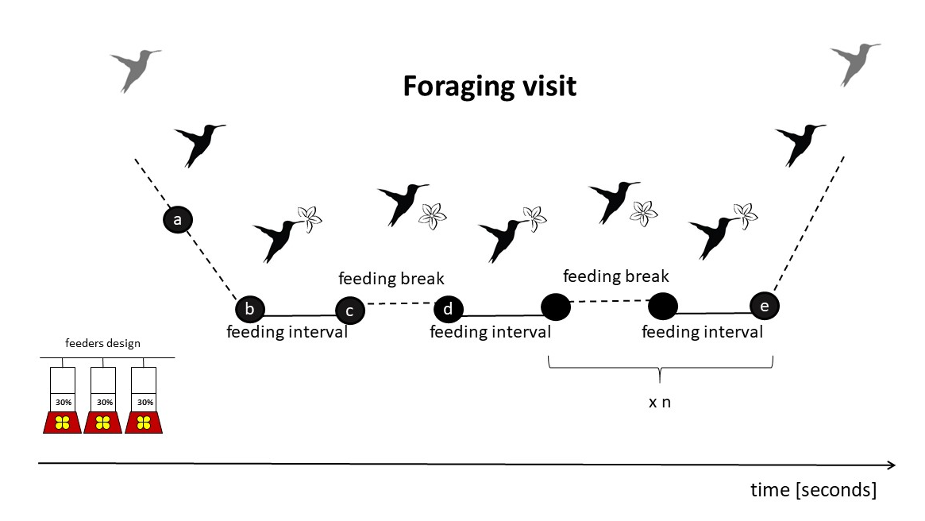

**Figure 2**. Repeatability estimates of foraging efficiency and behavioural parameters in the long billed hermit measured with linear mixed-effects models (Nakagawa and Schielzeth 2010).

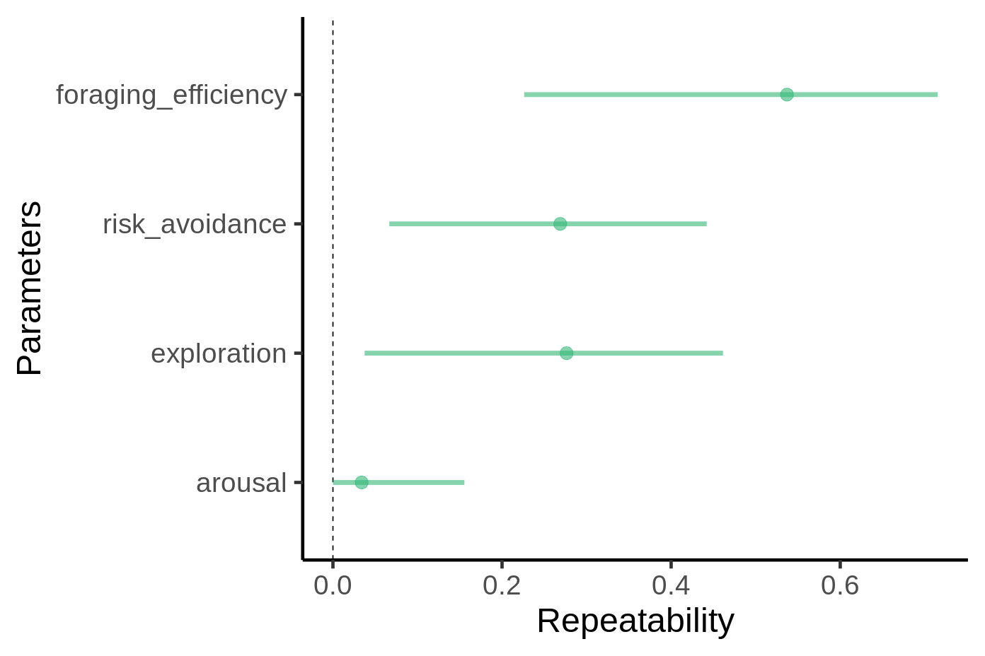

**Figure 3.** Foraging efficiency in the context of low and high levels of perceived risk of predation.

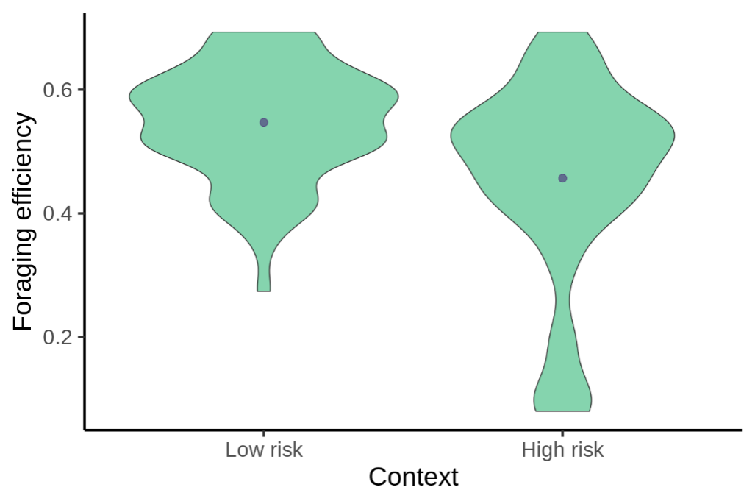

**Figure 4.** Foraging efficiency of long billed hermits in regard to their behavioural performance (exploration, risk avoidance and arousal) in the context of low and high levels of perceived risk of predation.

